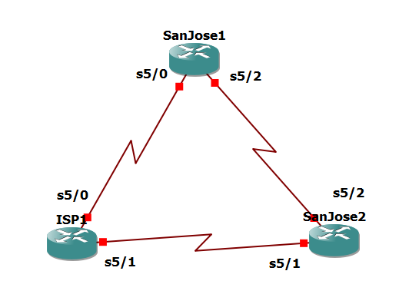

put this step in each router

Router(config)# no ip domain-lookup

line con 0

logging synchronous

exec-timeout 0 0

Router R1 (hostname ISP)

conf t

ISP(config)# interface Loopback0

ip address 192.168.100.1 255.255.255.0

exit

interface Serial5/0

ip address 192.168.1.5 255.255.255.252

clock rate 128000

no shutdown

exit

interface Serial5/1

ip address 192.168.1.1 255.255.255.252

no shutdown

end

Router R2 (hostname SanJose1)

conf t

SanJose1(config)# interface Loopback0

ip address 172.16.64.1 255.255.255.0

exit

interface Serial5/0

ip address 192.168.1.6 255.255.255.252

no shutdown

exit

interface Serial5/2

ip address 172.16.1.1 255.255.255.0

clock rate 128000

no shutdown

end

Router R3 (hostname SanJose2)

conf t

SanJose2(config)# interface Loopback0

ip address 172.16.32.1 255.255.255.0

exit

interface Serial5/1

ip address 192.168.1.2 255.255.255.252

clock rate 128000

no shutdown

exit

interface Serial5/2

ip address 172.16.1.2 255.255.255.0

no shutdown

end

SanJose1(config)# router eigrp 1

network 172.16.0.0

SanJose2(config)# router eigrp 1

network 172.16.0.0

SanJose1(config)# router bgp 64512

neighbor 172.16.32.1 remote-as 64512

neighbor 172.16.32.1 update-source lo0

SanJose2(config)# router bgp 64512

neighbor 172.16.64.1 remote-as 64512

neighbor 172.16.64.1 remote-as 64512

SanJose2# show ip bgp neighbors

ISP(config)# router bgp 200

neighbor 192.168.1.6 remote-as 64512

neighbor 192.168.1.2 remote-as 64512

network 192.168.100.0

SanJose1(config)# ip route 172.16.0.0 255.255.0.0 null0

SanJose1(config)# router bgp 64512

neighbor 192.168.1.5 remote-as 200

network 172.16.0.0

SanJose1# show ip bgp neighbors

SanJose2(config)# ip route 172.16.0.0 255.255.0.0 null0

router bgp 64512

neighbor 192.168.1.1 remote-as 200

network 172.16.0.0

SanJose2# show ip bgp summary

ISP# clear ip bgp *

ISP# ping 172.16.64.1

ISP# ping 172.16.1.1

ISP# ping 172.16.32.1

ISP# ping 172.16.1.2

ISP# show ip bgp

ISP# show ip bgp

ISP# ping 172.16.1.1 source 192.168.100.1

ISP# ping 172.16.32.1 source 192.168.100.1

ISP# ping 172.16.1.2 source 192.168.100.1

ISP# ping 172.16.64.1 source 192.168.100.1

ISP# ping

Target IP address: 172.16.64.1

Extended commands [n]: y

Source address or interface: 192.168.100.1

ISP(config)# router bgp 200

network 192.168.1.0 mask 255.255.255.252

network 192.168.1.4 mask 255.255.255.252

ISP# show ip bgp

SanJose2# show ip route

ISP(config)# router bgp 200

no network 192.168.1.0 mask 255.255.255.252

no network 192.168.1.4 mask 255.255.255.252

exit

interface serial5/1

shutdown

SanJose2# show ip bgp

SanJose2# show ip route

SanJose1(config)# router bgp 64512

neighbor 172.16.32.1 next-hop-self

SanJose2(config)# router bgp 64512

neighbor 172.16.64.1 next-hop-self

SanJose1# clear ip bgp *

SanJose2# clear ip bgp *

SanJose2# show ip bgp

SanJose2# show ip route

ISP(config-if)# no shutdown

SanJose2# show ip route

SanJose1(config)# route-map PRIMARY_T1_IN permit 10

set local-preference 150

exit

router bgp 64512

neighbor 192.168.1.5 route-map PRIMARY_T1_IN in

SanJose2(config)# route-map SECONDARY_T1_IN permit 10

set local-preference 125

exit

router bgp 64512

neighbor 192.168.1.1 route-map SECONDARY_T1_IN in

SanJose1# clear ip bgp * soft

SanJose2# clear ip bgp * soft

SanJose1# show ip bgp

SanJose2# show ip bgp

ISP# show ip bgp

ISP# show ip route

SanJose2# ping

Target IP address: 192.168.100.1

Extended commands [n]: y

Source address or interface: 172.16.32.1

Loose, Strict, Record, Timestamp, Verbose[none]: record

SanJose1(config)#route-map PRIMARY_T1_MED_OUT permit 10

set Metric 50

exit

router bgp 64512

neighbor 192.168.1.5 route-map PRIMARY_T1_MED_OUT out

SanJose2(config)#route-map SECONDARY_T1_MED_OUT permit 10

set Metric 75

exit

router bgp 64512

neighbor 192.168.1.1 route-map SECONDARY_T1_MED_OUT out

SanJose1# clear ip bgp * soft

SanJose2# clear ip bgp * soft

SanJose1# show ip bgp

SanJose2# show ip bgp

SanJose2# ping

Target IP address: 192.168.100.1

Extended commands [n]: y

Source address or interface: 172.16.32.1

ISP# show ip bgp

ISP(config)# router bgp 200

neighbor 192.168.1.6 default-originate

neighbor 192.168.1.2 default-originate

exit

interface loopback 10

ip address 10.0.0.1 255.255.255.0

SanJose1# show ip route

SanJose2# show ip route

SanJose2# show ip bgp

SanJose2# traceroute 10.0.0.1

ISP(config)# interface serial 5/0

shutdown

SanJose1# show ip route

SanJose2# show ip route

SanJose1# trace 10.0.0.1